12 DISTRIBUTION OF MAXWELL

Gas molecules at the movement constantly face. Speed of each molecule at collision changes. It can increase and decrease. However mean square speed remains invariable. This results from the fact that in the gas which is at a certain temperature some is established the stationary, not changing over time distribution of molecules on speeds which submits to a certain statistical law. Speed of a separate molecule can change eventually, however the share of molecules with speeds in some interval of speeds remains invariable.
You can not ask the question: how many molecules have a certain speed. The fact is that, although the number of molecules is very large in any even small volume, but the number of velocity values is arbitrarily large (like numbers in a sequential series), and it can happen that no molecule possesses a given speed.

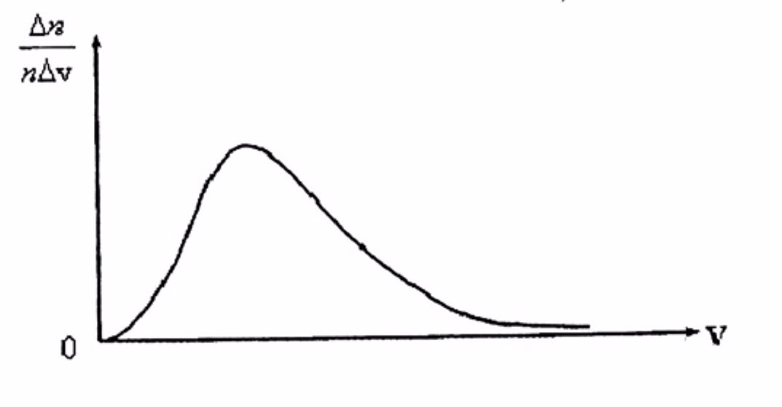
The figure 4 - Function of distribution of molecules on speeds or Maxwell's law

The problem of the velocity distribution of molecules should be formulated as follows. Let there be n molecules in a unit volume. What fraction of $\frac{∆n}{n}$ molecules has a velocity from v₁| до v₁ +Δv? This is a statistical problem.
Based on the experience of Stern, it can be expected that the largest number of molecules will have some kind of average speed, and the proportion of fast and slow molecules is not very large. The necessary measurements showed that the fraction of molecules $\frac{∆n}{n}$, referred to the speed interval Δv, i.e. $\frac{∆n}{nΔv}$, has the form shown in figure 4 Maxwell in 1859 theoretically, based on probability theory, determined this function. Since then, it is called the velocity distribution function of the molecules or the Maxwell law.
Analytically, it is expressed by the formula

$$\frac{∆n}{nΔv}=4π=({\frac{m}{2πkT})}^{\frac{3}{2}}v^{2}e^{-\frac{mv^{2}}{2πkT}}$$ | (73)

where m - is the mass of the molecule, k - is the Boltzmann constant.

The establishment of this dependence allowed us to determine, in addition to the already known rms velocity, two more characteristic velocities — the average and the most probable. Average velocity is the sum of the velocities of all molecules divided by the total number of all molecules in a unit volume.
The average speed calculated on the basis of Maxwell's law is expressed by the formula

$$v_{cp}=\sqrt{\frac{8kT}{πm}}$$ | (74)

Or

$$v_{cp}=\sqrt{\frac{8kT}{πµ}}$$ | (75)

The most likely speed is the speed, near which the largest number of molecules falls on a unit velocity interval.
It is calculated by the formula:

$$v_{вер}=\sqrt{\frac{2RT}{µ}}$$ | (76)

Comparing all three speeds:

1) the most likely $v_{вер}=\sqrt{\frac{2RT}{µ}}$≈$1.41\sqrt{\frac{RT}{µ}}$
2) average $v_{cр}=\sqrt{\frac{8RT}{πµ}}$≈$1.60\sqrt{\frac{RT}{µ}}$
3) the quadratic mean - $\sqrt{v^{-2}}≈1.73\sqrt{\frac{RT}{µ}}$ we see that the smallest of them is the most likely, and the largest is the mean square. The relative number of fast and slow molecules is small (Figure 5).

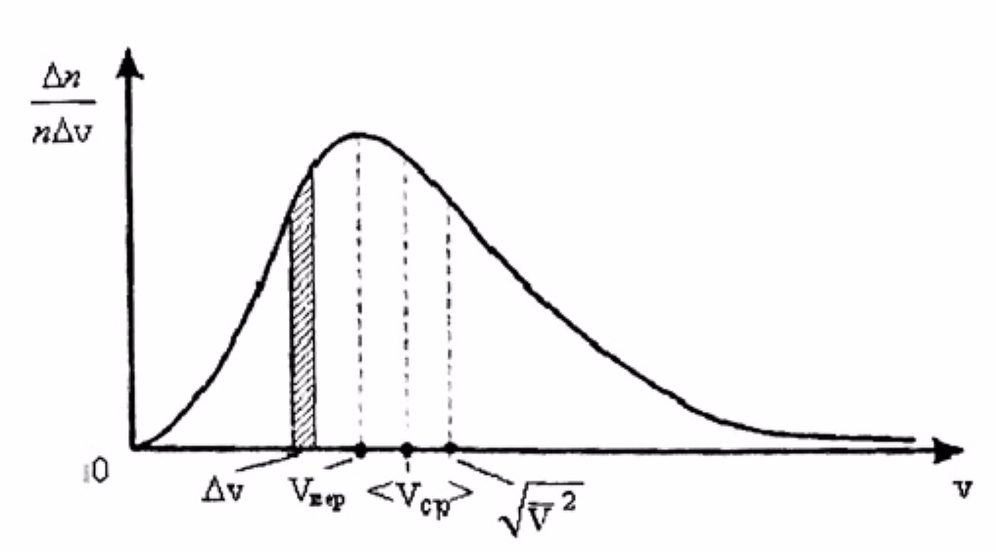
Figure 5 - The relative number of fast and slow molecules

When the gas temperature changes, the speeds of movement of all molecules, and, consequently, the most probable speed will change. Therefore, the curve maximum will shift to the right with increasing temperature and to the left with decreasing temperature. The height of the maximum will not remain constant. The point is that the area of the shaded figure is numerically equal to the fraction $\frac{∆n}{n}$ of the total number of molecules n, which is formed by molecules with speeds in the specified interval. The total area bounded by the distribution curve and the axis of abscissa (velocity) is thus equal to unity and does not change with temperature (figure 6). Therefore, the height of the maximum changes with temperature.

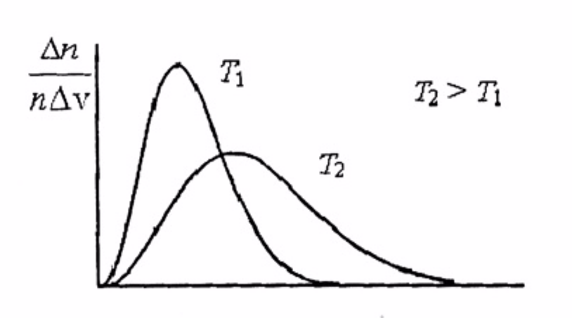
Figure 6 - The total distribution area

The velocity distribution curves of molecules begin at the origin of coordinates, asymptotically approaching the abscissa axis at infinitely high speeds. To the left of the maximum, the curves go steeper than the right. The fact that the distribution curve starts at the origin of coordinates means that there are no fixed molecules in the gas. From the fact that the curve asymptotically approaches the abscissa axis at infinitely high speeds, it follows that there are few molecules with very high speeds. This is easily explained. In order for a molecule to acquire a very high speed in collisions, it needs to get many such collisions in succession, in which it receives energy, and not a single collision in which it loses it. But this situation is unlikely.

